Author: Newman, J.N.  Publication journal: Advances in Applied Mechanics,  Primary argument:  This article discusses how ships are ocean environments that sometimes can be unsteady or even violent in motion which create a challenge for engineers.  Evidence article uses to support argument:  The article uses equations of motion and the principle of superposition to which allow engineers to calculate various forces and velocities.  Connection to your research project:  The motion of ships plays a vital role in the control and reading of the ship’s draft. | Insert a picture that you feel represents the article in the space below  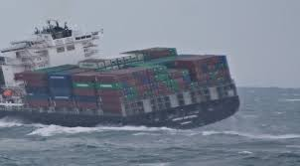  Article Title: Theory of Ship Motions  Publication date:1979

Author: Triantafyllou, Michael S.  Publication journal: Journal of Ship Research  Primary argument: Current plays a vital role in the movement of a ship in transit  Evidence article uses to support argument:  Article uses the strip method in the analysis of ship reactions as a result of ocean currents during motion.  Connection to your research project:  Current will greatly affect drift readings and the allowed draft for safe transit. | Insert a picture that you feel represents the article in the space below  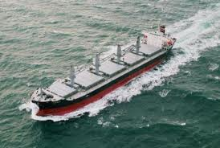  Article Title: STRIP THEORY OF SHIP MOTIONS IN THE PRESENCE OF A CURRENT  Publication date: Mar 1980

Author: Gualeni, P., Dazzi, N.  Publication journal: Transactions of the Royal Institution of Naval Architects Part A: International Journal of Maritime Engineering  Primary argument: Understanding the origins of Naval Architecture improves understanding of systems engineering  Evidence article uses to support argument:  Systems engineering provides a new approach to fixing naval ship design challenges.  Connection to your research project:  Understanding systems engineering and ship design will be helpful in figuring out how to integrate a ship draft reading system in naval vessels | Insert a picture that you feel represents the article in the space below  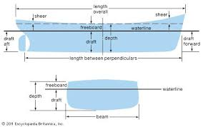  Article Title: Naval architecture and system engineering: A deal for naval ship design evolution  Publication date:1980-3

Author: Xin Ran, Chaojian Shi, Jinbiao Chen, Shijun Ying, and Keping Guan  Publication journal:2nd International Congress on Computer Applications and Computational Science  Advances in Intelligent and Soft Computing  Primary argument: Draft line method is a more efficient and effective method for reading a ship’s draft.  Evidence article uses to support argument:  Image processing is used to prevent man-made errors which may occur manual observations.  Connection to your research project:  Researching other methods for reading ship’s draft will provide insight to possible obstacles that our team may face during our design. | Insert a picture that you feel represents the article in the space below  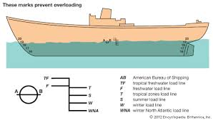  Article Title: Draft Line Detection Based on Image Processing for Ship Draft Survey  Publication date: 2012

