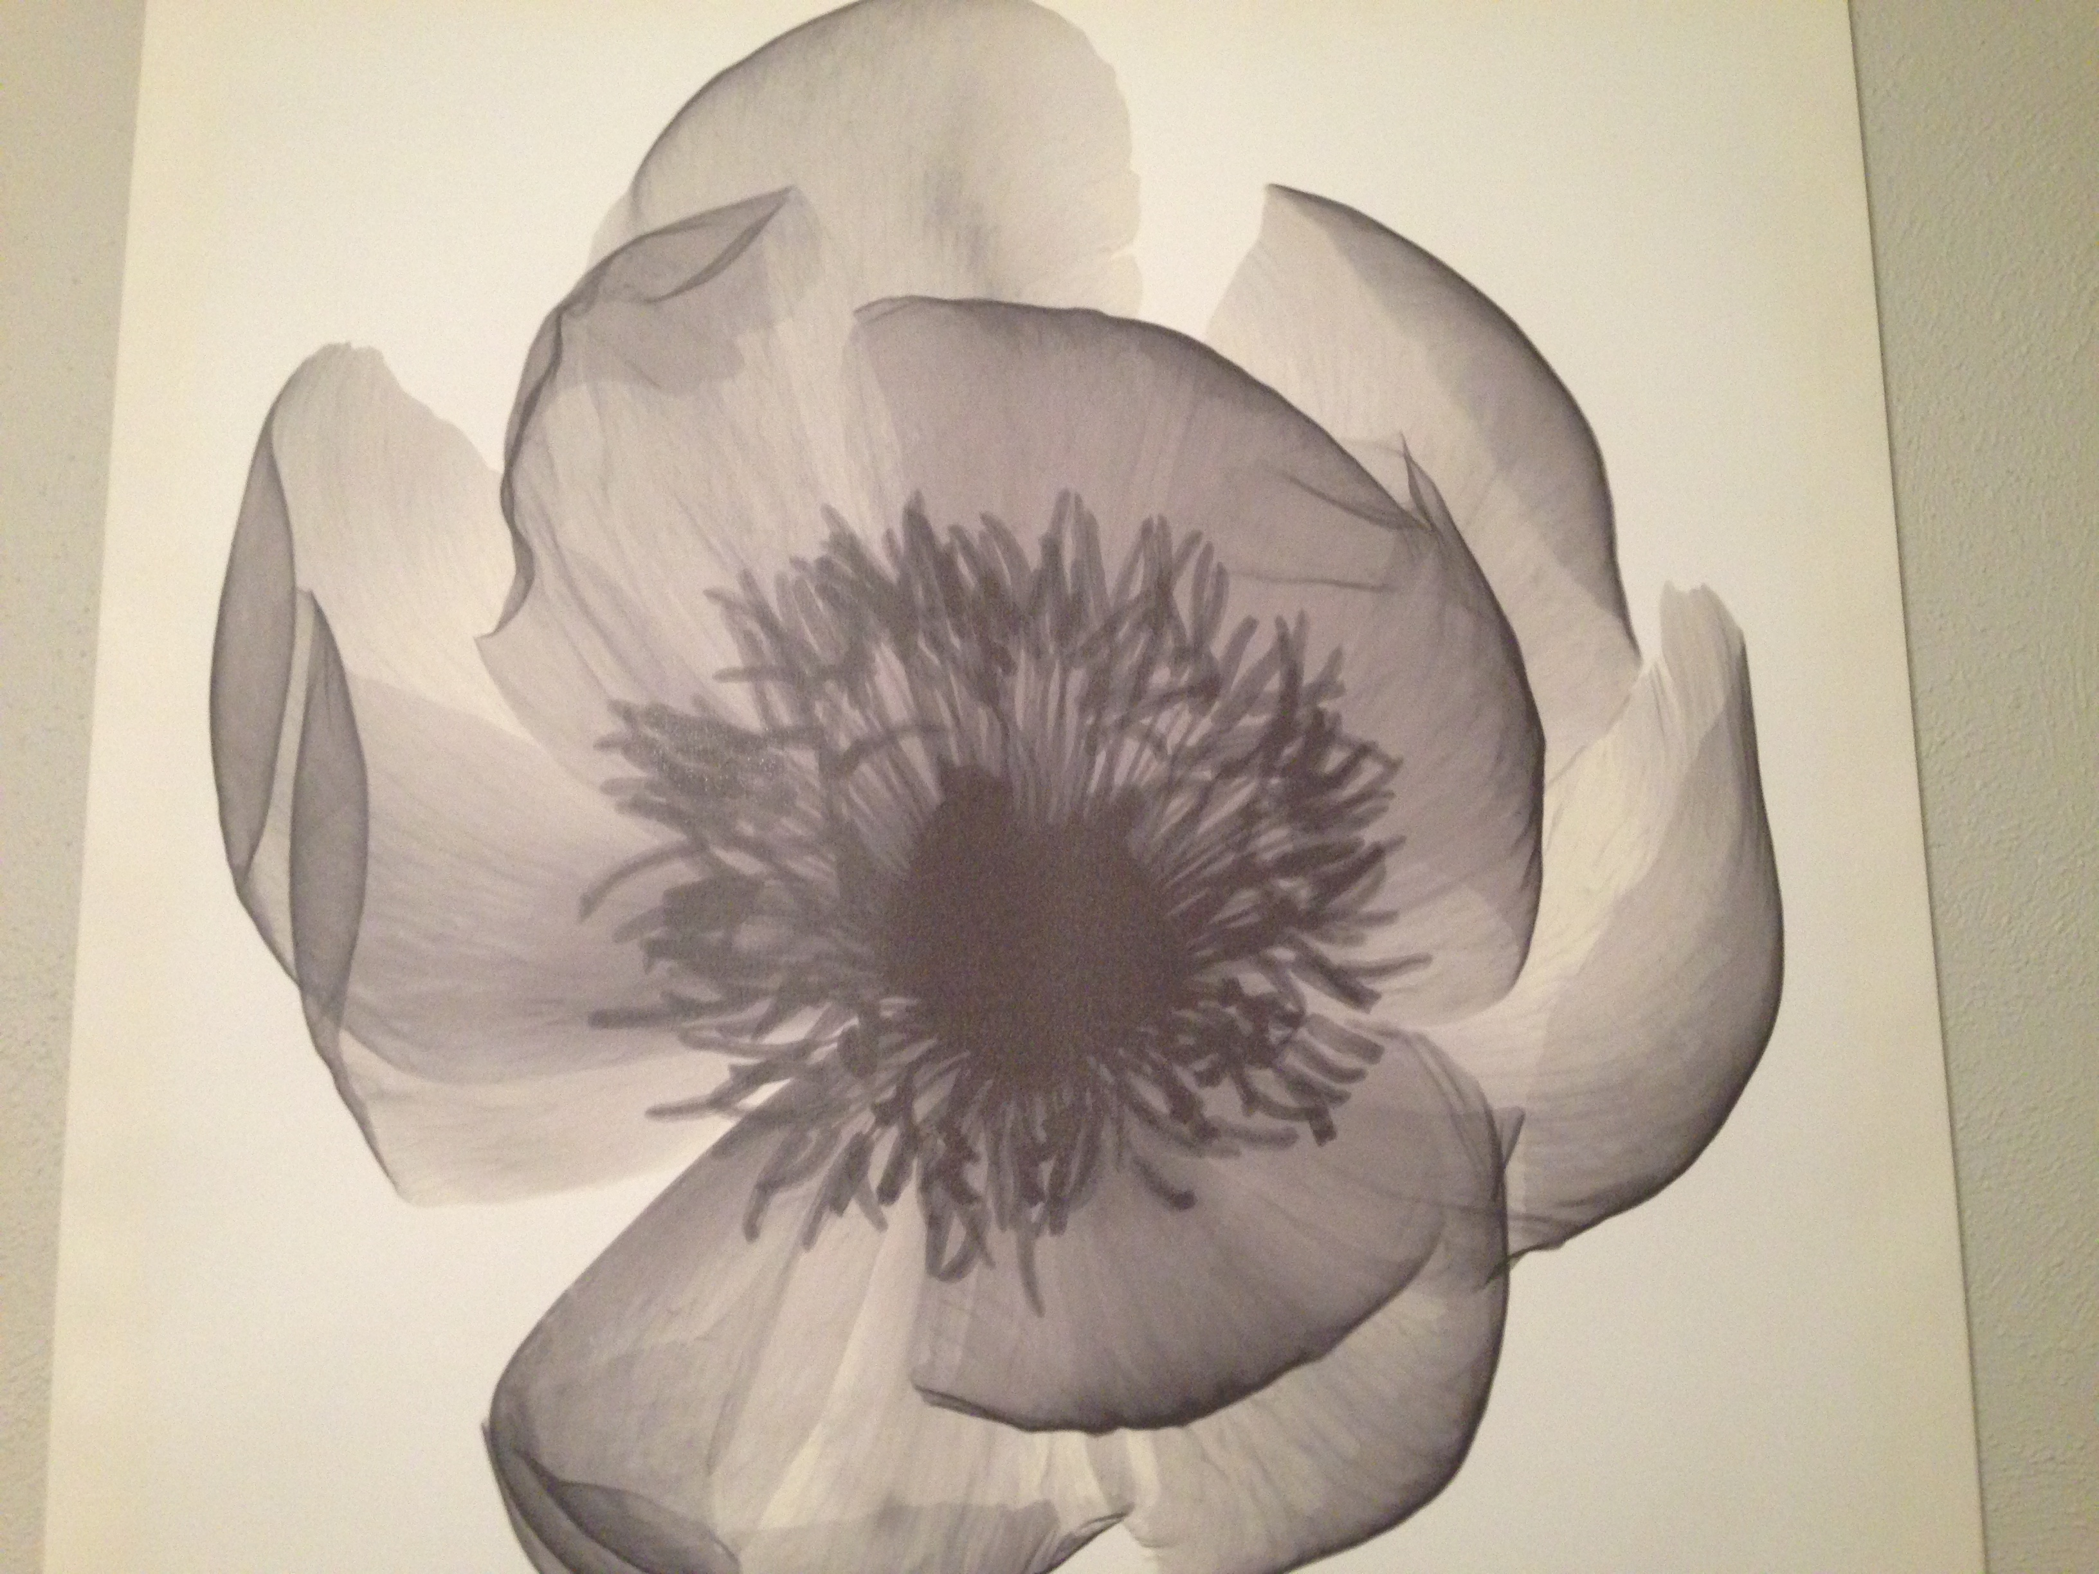
Discuss Protein Purification or Immunoglobulins

There are five major classes of immunoglobulins: IgM, IgA, IgD, IgG, and IgE. Each individual antibody consists of four linked polypeptide chains that form a monomeric unit. Two of the chains are dubbed “heavy” while the other two are dubbed “light. Each chain is composed of a constant region and a variable region. The variable region of each antibody is dependent on the antigen it is targeting. It is of note that the varying classes of immunoglobulins may be composed of linked monomeric units. For example, IgM is often found as a pentamer, five linked monomers, and IgA may be found as a monomer or dimer.

Flower+Immunoglobulins= http://www.plantphysiol.org/content/109/2/341.full.pdf

